Instructor: Dr. Jie Shen
Release date: Feb. 01, 2021
Due date: Feb. 08, 2021

Student Name: Demetrius Johnson
*Special note: see my lab uploads of the .CPP and .EXE files for ease of access and testing any of the programs for any question.

Table of Contents
Question 1 (3.0 points) 3
Source code (USED C++ COMPILER) 3
Test data and expected results 6
Question 2 (3.0 points) 9
Source code (USED C++ COMPILER) 9
Test data and expected results 11
Question 3 (4.0 points) 13
Source code (USED C++ COMPILER) 13
Test data and expected results 17
Submission 21
Provide an MS word document or a pdf file with the following information: 21

Question 1 (3.0 points)

Source code (USED C++ COMPILER)

// CIS-200-LAB 3 -DemetriusJohnson.cpp : This file contains the 'main' function. Program execution begins and ends there.
//

/*
//Author: Demetrius E Johnson
//Date: 7 FEB 2021
//Last Modification Date: 2-7-2021
//Purpose:

*/

/*
Question 1 (3.0 points)

Suppose you work for a boss who is stingy about memory use and
ask you to use only one unsigned char variable, x, for the representation of the binary status (ON or OFF) of 8 locations.
(See a figure below.) The reason for this is that your boss wants to use your code in handling with multiple-million user information.
In addition, your boss requires you to write a code for complete a number of steps as follows:

1) input a decimal number (0-255)
2) convert it to a binary number
3) loop throuhg all the bits of this binary number and print out the locations that correspond to the bit value as 1
//for example: if you have a binary number 10000001 (decimal: 129) then message output should be: "Garage, bedroom are on".
bit location representations:
0: garage
1: kitchen
2: hallway
3: basement
4: great room
5: family room
6: bathroom
7: bed room
Test your program with the following input numbers:

(a) 3
(b) 13
(c) 133

SIDE NOTES ON BITWISE OPERATORS:

***Bitwise operators return an integer value.
***The bitwise logical operators work on the data bit by bit, starting from the least significant bit,
i.e. LSB bit which is the rightmost bit, working towards the MSB (Most Significant Bit) which is the leftmost bit.
***The & (bitwise AND) in C or C++ takes two numbers as operands and does AND on every bit of two numbers. The result of AND is 1 only if both bits are 1.
*** The << (left shift) in C or C++ takes two numbers, left shifts ALL of the bits of the first operand, the second operand decides the number of places to shift.
***The >> (right shift) in C or C++ takes two numbers, right shifts ALL of the bits of the first operand, the second operand decides the number of places to shift.
*** when you use bitwise & operator in a conditional statement, it checks against the LSB (least significant bit); if the last bit each number == 1 (bit is on) then it evaluates to true.
*/

#include <iostream>
#include<vector>
using namespace std;

int main()
{

unsigned char x; //using char since it is only 8 bits of data--> 2^8 = 256 values possible; unsigned so that we get larger positive value storage range [0-255] instead of [-128 to 127]
int user_Decimal_Input = 0; //only need this integer in order to get user initial decimal value input
vector<short> c_Vec(8); //needed only so that we can print out the binary value in the correct order

cout << "-----WELCOME to the 8-bit room-lighting decimal to binary representation program----BY Demetrius Johnson------\n\n";
cout << " ON (1) and OFF (0) room-lighting bit (element) locations:\n\n0: garage\n1: kitchen\n2: hallway\n3: basement\n4: great room\n5: family room\n6: bathroom\n7: bed room\n";
cout << "\nFor Example --> if you input the decimal number: 129, it will be converted to the binary number: 10000001";
cout << "\nThen message output should be: 'garage, bedroom are ON' --> output of locations with light on (bit value = 1) will\nbe displayed from least to most significant bit.\n\n";

cout << "\nPlease input a decimal value in the range [0-255]: ";
cin >> user_Decimal_Input;
x = user_Decimal_Input; //store the user data inside of the smallest integral data type (char/unsigned char == 1 byte == 8 bits)

cout << "\n\tThe binary value of the decimal value " << user_Decimal_Input << " is equal to: ";

for (int i = 7; i >= 0; i--) {

c_Vec.at(i) = (x % 2); //set the proper bit of the 8-bit binary number using the formula of division by 2 and keeping the remainder,
//starting with the LSB (right most bit == least significant bit)
x /= 2; // divide by two to get to the next place value

}
x = user_Decimal_Input; //re-input the user's integer value input since it was manipulated by the above function
for (int j = 0; j < 8; j++) { cout << c_Vec.at(j); } //output the binary number

if (x > 0) { cout << endl << endl << "\tThe "; } //use this only if at least one bit is on
for (int k = 7; k >= 0; k--) { //this loop will go from LSB to MSB for output as the program specified it would do for bits that are ON

switch (k) {

case 7:
if (c_Vec.at(k)) { cout << "Garage, "; } break;
case 6:
if (c_Vec.at(k)) { cout << "Kitchen, "; } break;
case 5:
if (c_Vec.at(k)) { cout << "Hallway, "; } break;
case 4:
if (c_Vec.at(k)) { cout << "Basement, "; } break;
case 3:
if (c_Vec.at(k)) { cout << "Great Room, "; } break;
case 2:
if (c_Vec.at(k)) { cout << "Family Room, "; } break;
case 1:
if (c_Vec.at(k)) { cout << "Bathroom, "; } break;
case 0:
if (c_Vec.at(k)) { cout << "Bedroom, "; } break;
}
}

cout << "\b\b "; //use this to clear off last ',' character
if (x > 0) { cout << "is/are ON."; } //more than one bit ON
else { cout << "No rooms are on (all bits OFF)."; } //no bits ON; all OFF
cout << endl << endl << "The program has finished execution....now exiting...thank you....\n\n";
system("pause");

return 0;
}

Test data and expected results

Test Table:
Test # | Valid / Invalid Data | Description of test | Input Value | Expected Output | Actual Output | Test Pass / Fail
1 | valid | Testing to see if binary is correct and if corresponding on bits display proper locations | Decimal val = 3 | Binary: 00000011  Locations for 1’s | See screenshot | pass
2 | valid | Testing to see if binary is correct and if corresponding on bits display proper locations | Decimal val = 13 | Binary: 00001101  Locations for 1’s | See screenshot | pass
3 | valid | Testing to see if binary is correct and if corresponding on bits display proper locations | Decimal val = 133 | Binary: 10000101  Locations for 1’s | See screenshot | pass
4 | valid | Testing with no rooms on (all 0’s) | Decimal val = 0 | Binary: 00000000  Locations for 1’s | See screenshot | pass
5 | valid | Testing with all bits ON (all 1’s = 255) | Decimal val = 255 | Binary: 11111111  Locations for 1’s | See screenshot | pass

TEST 1:

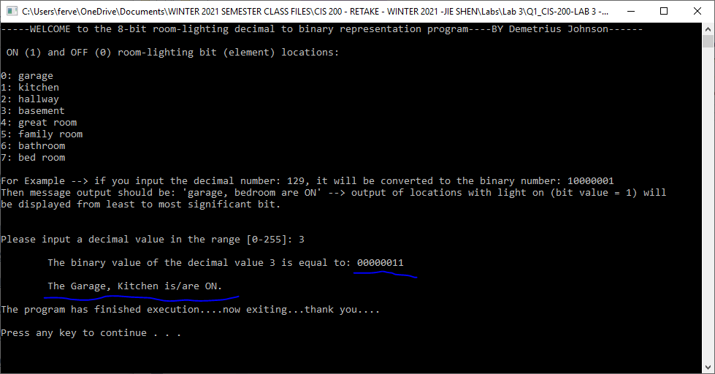

TEST 2:
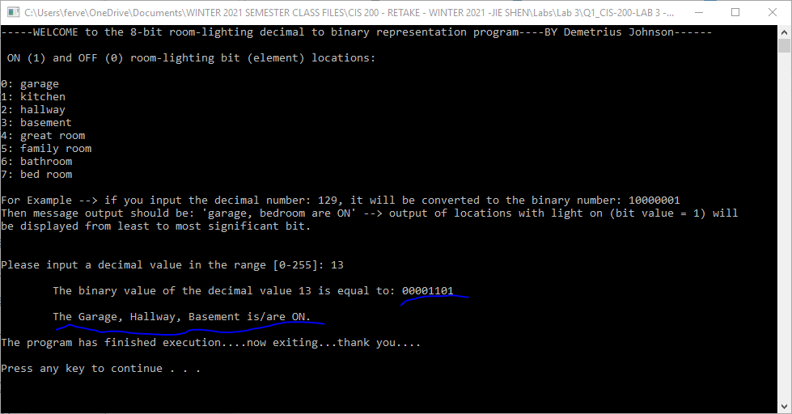

TEST 3:

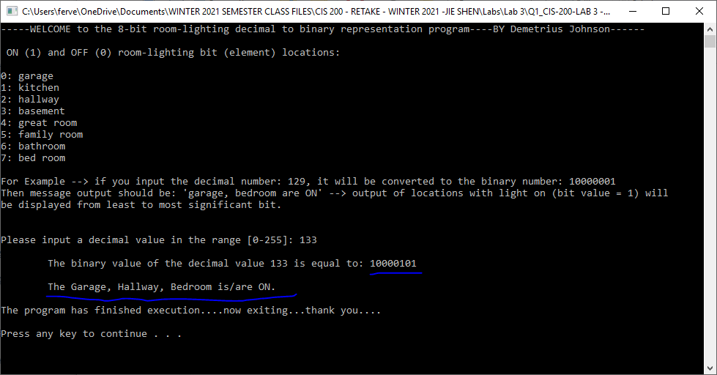

TEST 4:
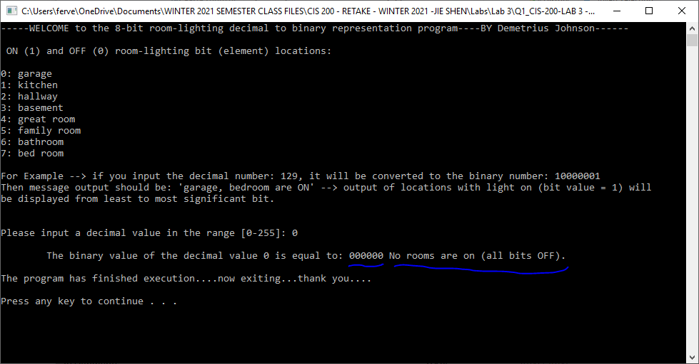

TEST 5:

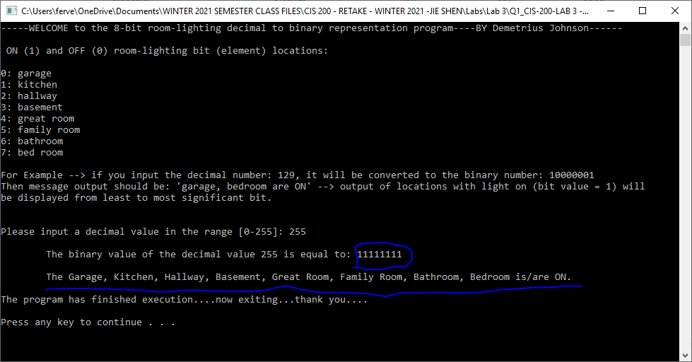

Question 2 (3.0 points)

Source code (USED C++ COMPILER)
// CIS-200-LAB 3 -DemetriusJohnson.cpp : This file contains the 'main' function. Program execution begins and ends there.
//

/*
//Author: Demetrius E Johnson
//Date: 7 FEB 2021
//Last Modification Date: 2-7-2021
//Purpose:

*/

/*

Question 2 (3.0 points)
Write a program to determine whether the character entered is a capital letter, a small case letter, a digit or a special symbol.
The following table shows the range of ASCII values for various characters.
Characters ASCII Values
A – Z 65 – 90
a – z 97 – 122
0 – 9 48 – 57
special symbols 0 - 47, 58 - 64, 91 - 96, 123 – 127

In your main( ), you should declare a char variable ch and get a user input from keyboard for ch.
Based on the above ASCII table,
print out a message to show that the input character is an upper case or a lower case or a digit or a special symbol.

User test inputs:
Y
t
5
*

*/

#include <iostream>
using namespace std;

int main()
{
char ch;
char user_Decide = 121; //121 == 'y' //use this variable so user can decide wether or not to exit program

do { //made this loop so it will be easier to test multiple values until it is desired to exit the program

cout << "-----WELCOME to the simple character type determination program----BY Demetrius Johnson------\n\n";
cout << " This program will take the user character input and determine which category it belongs to:\n\n\t*Upper-case Letter\n\t*Lower-case Letter\n\t*Digit\n\t*Special Symbol\n\n";
cout << "Input a single character: ";
cin >> ch;
cout << endl << "Your character '" << ch << "' is a ";

if (ch > 47 && ch < 58) { cout << "Digit."; }
else if (ch > 64 && ch < 91) { cout << "Upper-case Letter."; } //using the if-else statements to funnel down from smallest decimal to largest
else if (ch > 96 && ch < 123) { cout << "Lower-case Letter."; } // for determining what type of character the user has input
else { cout << "Special Symbol."; }

cout << "\n\nEnter 'y' to restart program; enter any other character to exit: ";
cin >> user_Decide;
cout << endl << endl;

} while (user_Decide == 121); //121 == 'y'

cout << "\n\nProgram exit option selected...exiting program....thank you.....goodbye(:";
cout << endl;
system("pause");
return 0;
}

Test data and expected results

Test Table:
Test # | Valid / Invalid Data | Description of test | Input Value | Expected Output | Actual Output | Test Pass / Fail
1 | valid | Test upper case letter | Y | UC letter | See screenshot | pass
2 | valid | Test lower case letter | t | LC letter | See screenshot | pass
3 | valid | Test digit | 5 | Digit | See screenshot | pass
4 | valid | Test special symbol | * | Special Symbol | See screenshot | pass

TEST 1:
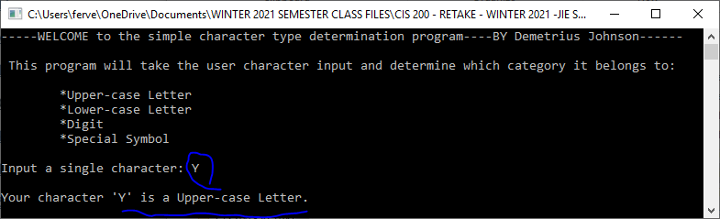

TEST 2:
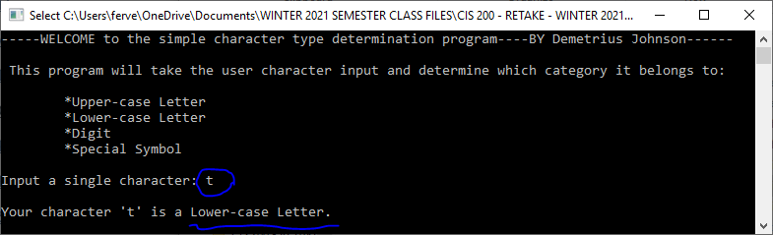

TEST 3:
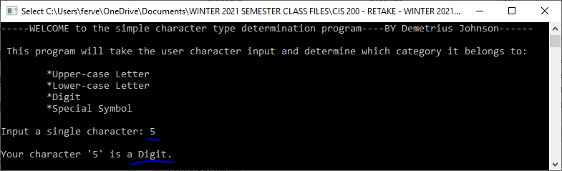

TEST 4:
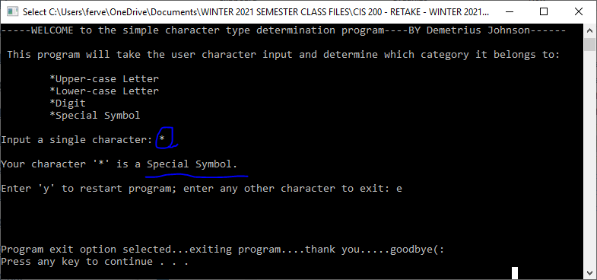

Question 3 (4.0 points)

Source code (USED C++ COMPILER)
// CIS-200-LAB 3 -DemetriusJohnson.cpp : This file contains the 'main' function. Program execution begins and ends there.
//

/*
//Author: Demetrius E Johnson
//Date: 7 FEB 2021
//Last Modification Date: 2-7-2021
//Purpose:

*/

/*
Question 3 (4.0 points)

Given that Sale[NUM_ROW][NUM_COLUMN] is a two dimensional array of float-pofloat type and the two constants are defined as follows:

#define NUM_ROW 4
#define NUM_COLUMN 4

float Value[NUM_ROW][NUM_COLUMN] =
{ 5.1, 5.2, 5.3, 5.4, 4.5, 4.6, 4.7, 4.8, 4.9, 3.0, 3.1, 3.2,
3.1, 3.2, 3.3, 3.4
};

Write a C++ main function that computes and prints out the following information about this 2d array:

(1) The minimum value of Value[][] array elements (1 points).
(2) The maximum value of the Value[][] array elements (1 points).
(3) The mean of all the Value[][] array elements (1 points).
(4) The values of four neighboring elements with respect to Value[i][j], where i and j represent the row and column, respectively.
Your program should ask users to input i and j, and then the code should prfloat out the values of all the four neighboring elements w.r.t. i and j.
The four neighboring elements are defined as the elements at the left, right, up, and down positions adjacent to the element [i][j].

User test cases:
(a) i = 1, j=1
(b) i = 0, j =2
(c) i= 2, j=3

You need to prfloat the results on computer screen and make a screenshot.

Hint: You should consider wrap-around when element[i][j] is located at the boundary of the matrix.

//remember for array[i][j]; the i is row, j is column
//also remember arrays are by default passed by reference into functions

*/

#include <iostream>
#include<vector>
#define NUM_ROW 4
#define NUM_COLUMN 4
using namespace std;

//FUNCTION DECLARATIONS

float minVal_2D_Arr(float valueArr[][NUM_COLUMN]);
float maxVal_2D_Arr(float valueArr[][NUM_COLUMN]);
float meanVal_2D_Arr(float valueArr[][NUM_COLUMN]);
vector<float> neighbor_Horz_Vert_values_2D_Arr(float valueArr[][NUM_COLUMN], int row, int col);

//FUNCTION DECLARATIONS

int main()
{

//2-D array below:
float value[NUM_ROW][NUM_COLUMN] =
{ 5.1, 5.2, 5.3, 5.4,
4.5, 4.6, 4.7, 4.8,
4.9, 3.0, 3.1, 3.2,
3.1, 3.2, 3.3, 3.4 };

//cout << value[1][0]; //used for testing; note, since multi-demensional arrays are really stored as 1D arrays, cout << value[0][4] will yield the same as cout << [1][0]
cout << "---WELCOME---this simple program takes a 2D array and ouputs various metrics about the array---BY Demetrius Johnson----\n\n";
cout << "Here is the 2D array used: \n\n{ 5.1, 5.2, 5.3, 5.4,\n 4.5, 4.6, 4.7, 4.8,\n 4.9, 3.0, 3.1, 3.2,\n 3.1, 3.2, 3.3, 3.4 }\n\n";

cout << "The MINIMUM value of the 2D array is: " << minVal_2D_Arr(value) << endl;
cout << "The MAXIMUM value of the 2D array is: " << maxVal_2D_Arr(value) << endl;
cout << "The MEAN value of the 2D array is: " << meanVal_2D_Arr(value) << endl << endl;
cout << "Now, the program will compute the up-down-left-right neighbors from user input concerning an element in the array.\n";

int Row, Col; //will use these to ask for user input for calling the neighbor funtion

cout << "The 2D-Array form is this: [ROW][COLUMN] --> [i][j]\n\n";
cout << "Input which ROW your element is in ( row elements go from 0 to 3 = 4 elments): ";
cin >> Row;
cout << "Input which COLUMN your element is in (col elements go from 0 to 3 = 4 elments): ";
cin >> Col;
cout << "Your element position " << "[" << Row << "][" << Col << "] {value = " << value[Row][Col] << "} has these 4 values as neighbors: \n\n";

vector<float> output_Neighbor_Vec(4);
output_Neighbor_Vec = neighbor_Horz_Vert_values_2D_Arr(value, Row, Col);

for (int count = 0; count < 4; count++) {

switch (count) {

case 0: cout << "Right Neighbor: " << output_Neighbor_Vec.at(count) << endl; break;
case 1: cout << "Left Neighbor: " << output_Neighbor_Vec.at(count) << endl; break;
case 2: cout << "Top Neighbor: " << output_Neighbor_Vec.at(count) << endl; break;
case 3: cout << "Bottom Neighbor: " << output_Neighbor_Vec.at(count) << endl; break;

}
}

cout << endl << endl;
cout << "Program has finished execution....exiting....thank you....\n";
system("pause");
return 0;
}

//FUNCTION DEFINITIONS

float minVal_2D_Arr(float valueArr[][NUM_COLUMN]){

float minVal = valueArr[0][0]; //initialize the the minVal variable to the very first value in the 2D array as a starting minVal point

for (int row = 0; row < 4; row++) {

for (int column = 0; column < 4; column++) {

if (minVal > valueArr[row][column]) { minVal = valueArr[row][column]; } //check each element using the two for-loops against current min
//which control the row and column number iteration respectively
}
}

return minVal;
}

float maxVal_2D_Arr(float valueArr[][NUM_COLUMN]) {

float maxVal = valueArr[0][0]; //initialize the the maxVal variable to the very first value in the 2D array as a starting minVal point

for (int row = 0; row < 4; row++) {

for (int column = 0; column < 4; column++) {

if (maxVal < valueArr[row][column]) { maxVal = valueArr[row][column]; } //check each element using the two for-loops against current max
//which control the row and column number iteration respectively
}
}

return maxVal;
}

float meanVal_2D_Arr(float valueArr[][NUM_COLUMN]){

float sum = 0;
float numVal = 0;
float values_summed = 0;
float meanVal = 0;

for (int row = 0; row < 4; row++) {

for (int column = 0; column < 4; column++) {

sum += valueArr[row][column]; //add the current element value to the mean
values_summed++;
}
}
meanVal = (sum / values_summed);
return meanVal;
}

vector<float> neighbor_Horz_Vert_values_2D_Arr(float valueArr[][NUM_COLUMN], int row, int col){

vector<float> neighbor_Vec(4); // VECTOR ELEMENTS: right neighbor = 0, left neighbor = 1, top neighbor = 2, bottom neighbor = 3
//note: left and right neighbors depend on the adjacent columns, up and down nieghbors depend on the adjacent rows

neighbor_Vec.at(0) = valueArr[row][((col + 1) % 4)]; //use +1 and % 4 since elements range from 0-3,
//which means if col == 3, (3+1) % 4 = 0; if col == 0, then (0+1) % 4 = 1
//--> will handle the wrap-around case for defining right neighbors (column 3 elements)
//as well as normal cases for right nieghbor

neighbor_Vec.at(1) = valueArr[row][((col + 3) % 4)]; //+3 in this case to find left neighbors and account for wrap-around case (column 0 elements)
neighbor_Vec.at(2) = valueArr[((row + 3) % 4)][col]; //top neighbors including wrap-around case (row 0)
neighbor_Vec.at(3) = valueArr[((row + 1) % 4)][col]; //bottom neighbors including wrap-around case (row 3)

return neighbor_Vec;
}

//FUNCTION DEFINITIONS

Test data and expected results

2D ARRAY TABLE:
Row  Elements:0 | 1 | 2 | 3 | Column Elements:
5.1 | 5.2 | 5.3 | 5.4 | 0
4.5 | 4.6 | 4.7 | 4.8 | 1
4.9 | 3.0 | 3.1 | 3.2 | 2
3.1 | 3.2 | 3.3 | 3.4 | 3

Test Table:
Test # | Valid / Invalid Data | Description of test (testing for proper neighbor outputs) | Input Value (row, col) | Expected Output | Actual Output | Test Pass / Fail
1 | valid | Test normal element | 1,1 | Should have 4-neighbors including wrap-around cases | See screenshot | pass
2 | valid | Test end-element | 0,2 | Should have 4-neighbors including wrap-around cases | See screenshot | pass
3 | valid | Test normal element | 2,3 | Should have 4-neighbors including wrap-around cases | See screenshot | pass
4 | valid | Test corner element for wrap-around | 0,0 | Should have 4-neighbors including wrap-around cases | See screenshot | pass
5 | valid | Test corner element for wrap-around | 3,3 | Should have 4-neighbors including wrap-around cases | See screenshot | pass

TEST 1:

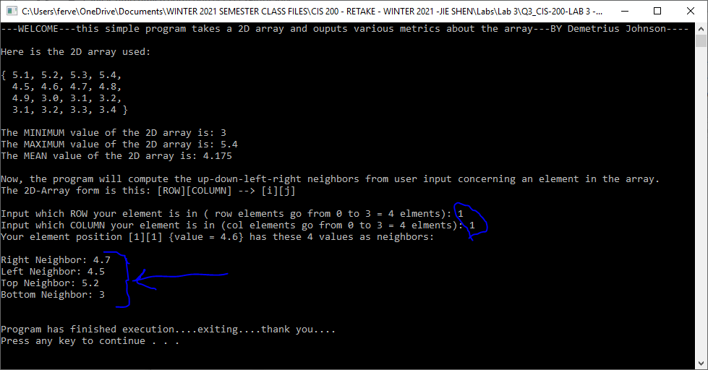

TEST 2:
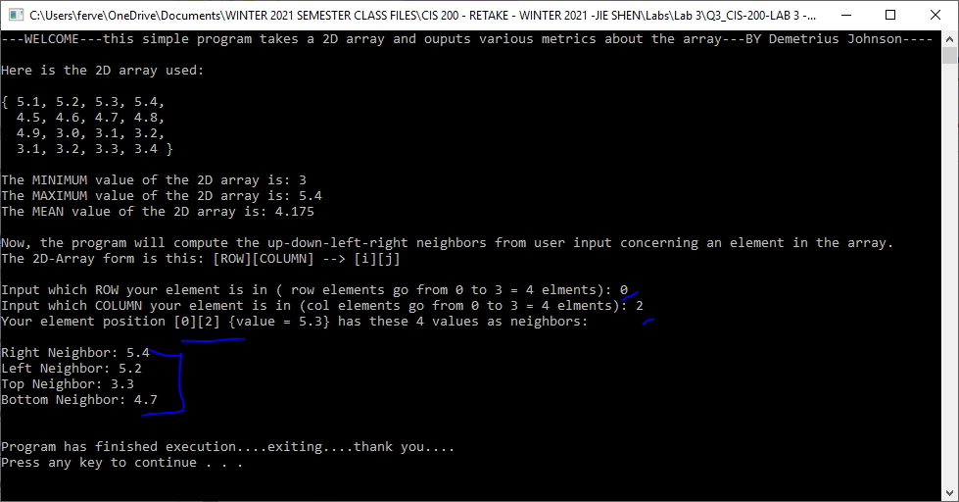
TEST 3:
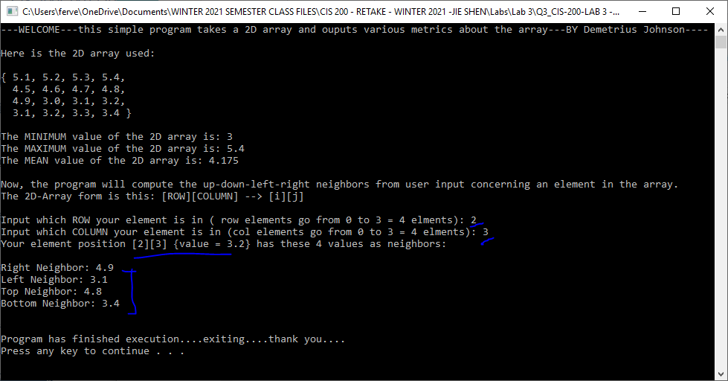
TEST 4:
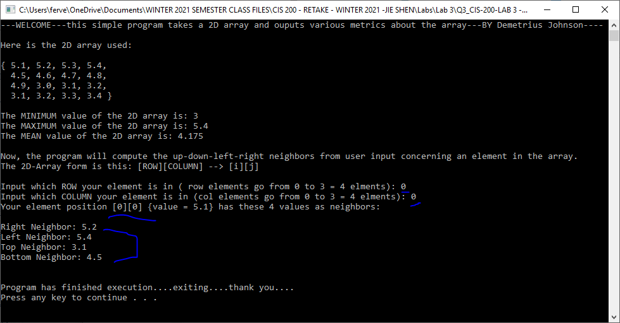
TEST 5:
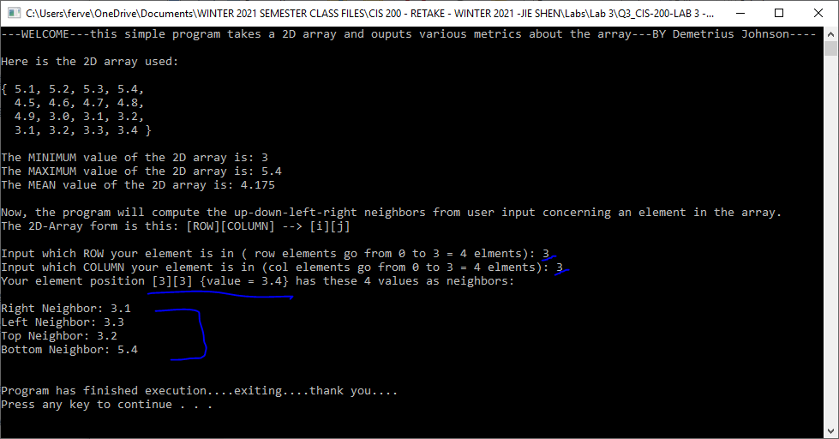

Submission

Provide an MS word document or a pdf file with the following information:
- Cover page with lab number and title, your name, date
- Test data and expected results
- Running log/output (screen shots should be provided)
- Insert the source code and screenshots into the word document
- You should submit your work through Canvas site for cis 200 lab.
- The filename of the word document should follow the convention: FirstName_LastName_Cis200Lab3.doc or pdf.

